5/13/2015

Duc HN

FPT University

SOFTWARE PROJECT MANAGEMENT PLAN

Contents

I. Introduction 1

1. Project Overview 1

2. Project Deliverables 2

3. Reference Materials 2

4. Definitions and Acronyms 2

II. Project Organization 3

1. Process Model 3

2. Organizational Structure 3

3. Other Organizational Or Process-related Information 3

4. Project Responsibilities 3

III. Managerial Process 4

1. Management Objectives and Priorities 4

2. Assumptions, Dependencies, and Constraints 4

2.1. Constraints 4

2.2. Assumptions 4

3. Risk Management 4

4. Monitoring and Controlling Mechanisms 4

5. Staffing Plan 4

IV. Technical Process 5

1. Methods, Tools, and Techniques 5

1.1. Tools 5

1.2. Techniques 5

1.3. Methods 5

2. Software Documentation 5

3. Project Support Functions 6

# Introduction

## Project Overview

* **Project Name:** Fly Away Plus
* **Sponsor’s name: Nguyễn Văn Sang –** [**SangNV@fpt.edu.vn**](mailto:SangNV@fpt.edu.vn)
* **Members:**
  + Hoàng Nghĩa Đức – [DucHNSE02882@fpt.edu.vn](mailto:DucHNSE02882@fpt.edu.vn) - Project Manager
  + Dương Thanh Hải – [HaiDT@fpt.edu.vn](mailto:HaiDT@fpt.edu.vn) – Team Member
  + Nguyễn Minh Hoàng - [HoangNMSE02819@fpt.edu.vn](mailto:HoangNMSE02819@fpt.edu.vn) - Team member
  + Trần Mạnh Hiếu – [HieuTMSE02778@fpt.edu.vn](mailto:HieuTMSE02778@fpt.edu.vn) – Team Member
  + Lê Minh Thúy – [ThuyLMSE02881@fpt.edu.vn](mailto:ThuyLMSE02881@fpt.edu.vn) – Team Member
  + Phan Tiến Lực – [LucPTSE02923@fpt.edu.vn](mailto:LucPTSE02923@fpt.edu.vn) - Team member
* **Project Objectives:**

Provide a web system help:

* People who love traveling

## Project Deliverables

* Project plan
* Source code
* Test report
* Test plan
* Schedule plan
* Milestone report
* Performance report
* Weekly report
* Bug list
* Detailed Design

## Reference Materials

Managing Information Technology Projects (sixth edition) – Kathy Schwalbe, Ph.D., PMP Augsburg College.

## Definitions and Acronyms

|  |  |
| --- | --- |
| **Acronyms** | **Definitions** |
| PM | Project Manager |
| TM | Team Member |
| TL | Team Leader |
| QA | Quality Assurance |
| WBS | Work Breakdown Structure |
| WR | Weekly report |
| CM | Configuration Manager |
| QAL | Quality Assurance Leader |
| OS | Operation System |

# Project Organization

## Process Model

* Use waterfall development to approach and develop the system.

## Organizational Structure

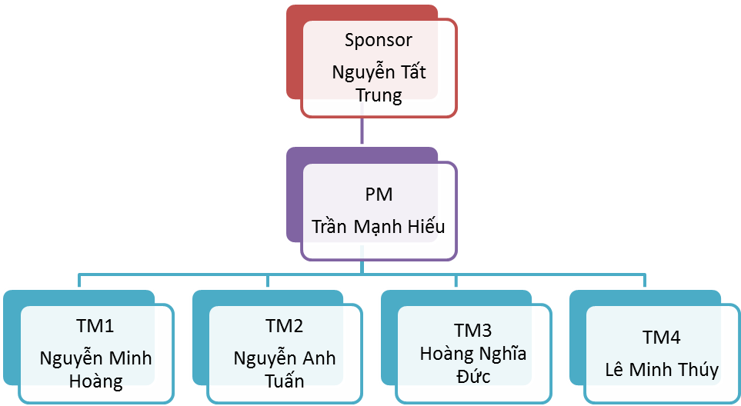

## Other Organizational Or Process-related Information

* All members must take part in developing phase of the project.
* Use SVN to manage software version, resources.
* Hold daily progress meeting with all members in the morning.

## Project Responsibilities

|  |  |  |  |
| --- | --- | --- | --- |
| **Name** | **Role** | **Position** | **Contact Information** |
| Trần Mạnh Hiếu | PM | Manage Project | hieutmse02778@fpt.edu.vn |
| Nguyễn Minh Hoàng | TM1 | Programmer | hoangnmse02819@fpt.edu.vn |
| Nguyễn Anh Tuấn | TM2 | Programmer | tuannase02792@fpt.edu.vn |
| Hoàng Nghĩa Đức | TM3 | Programmer | [duchnse02882@fpt.edu.vn](mailto:duchnse02882@fpt.edu.vn) |
| Lê Minh Thúy | TM4 | Tester | [thuylmse02881@fpt.edu.vn](mailto:thuylmse02881@fpt.edu.vn) |

# Managerial Process

## Management Objectives and Priorities

* Refer to Work Breakdown Structure in files: **BMO_WBS.mpp**

## Assumptions, Dependencies, and Constraints

### Constraints

* + This project is appropriated for all Android OS, iOS, Windows Phone and web

### Assumptions

* + All books would be sale on the store have to be copyright by author or publisher
  + Author who upload illegal books (without copyright or have illegal content) could be blocked or banned.
  + User who want to sales books have to register with legal information

## Risk Management

* Risk Management will be managed in a excel file: **RiskManagement.xlsx**

## Monitoring and Controlling Mechanisms

* Ensure the team is working on the correct activities
* Ensure the team is on-schedule
* Ensure the team is on-budget
* Ensure the quality of the work is acceptable
* Ensure project control activities can be performed if deviations from the plan are identified

## Staffing Plan

* Refer to Work Breakdown Structure in files: **BMO_WBS.mpp**

# Technical Process

## Methods, Tools, and Techniques

## Tools

* On android OS:
  + Android Studio
  + SVN
  + JRE 1.6
  + Window 8 OS Ram 4Gb
* On web and Windows phone:
  + Visual Studio 2013
  + .NET Framework 4
  + Tortoise SVN
  + Windows 8 4GB Ram
* On iOS:
  + Mac computer running OS X 10.9.4 or later
  + Xcode (latest version)
  + iOS SDK

## Techniques

* Use waterfall model to develop the project

## Methods

* + Top-down Approach

## Software Documentation

* Milestone report
* Test document
* Performance report
* Weekly report
* Bug list
* Detailed Design
* Meeting report
* Risk Management
* Q&A
* Change management
* Specification
* Analyze document
* Issues management

## Project Support Functions